Faculty of Computing



[CCN]
Lab No 7 Tasks

Task 1:
Send a ping command for both HUB and SWITCH network using command prompt in packet tracer and notice the results in simulation mode.
Scenario:
Create simplest hub-based and switched-based networks, ideal for studying the different processes between hubs and switches. Add generic PCs and 2950-24 switches for one topology and generic hub with PCs the other topology.
Set the IP addresses ranging from 192.168.1.1 to 192.168.1.5 for one topology and 192.168.2.1 to 192.168.2.5 for another topology. All should have subnet masks 255.255.255.0.
Reflect:
Go to simulation mode. In event list filters, enable only ICMP and ARP. Using the “Simple PDU”, issue a ping from PC 0 to PC 1. Play the simulation. Pay close attention to how the hub processes the ICMP and ARP packets. After that, once again, use” Add simple PDU to issue a ping from PC1 to PC 0. Play the simulation again. How has the behavior of the hub changed from the first and second attempts, if at all?
Still in simulation mode, in the event List Filters, enable only ICMP and ARPO. Using the Add simple PDU issue a ping from PC 3 to PC 4. Play the simulation. Pay close attention to how the switch processes the ICMP and ARP packets. Now check for the behavior for the Switch.
In what ways did the switch processes the packets similarly or differently from Hub between the first and second ping attempts?
Task 2:
For the switched based network, set the new IP address and subnet mask for the PCs as follows.
PC | IP ADDRESSES | SUBNET MASK
PC0 | 192.168.1.36 | 255.255.255.224
PC1 | 192.168.1.37 | 255.255.255.224
PC2 | 192.168.1.38 | 255.255.255.224
PC3 | 192.168.1.91 | 255.255.255.224
Tell about the communication. Communicated or not? If yes why.

Task 3:
Create a star topology using a class A addressing scheme. Use Router to connect the end devices. Explain the behavior of the ping on each device. Use one router with 4 networks, 2 switches and 1 hub.
Task 4:
Create the topology shown in the below diagram
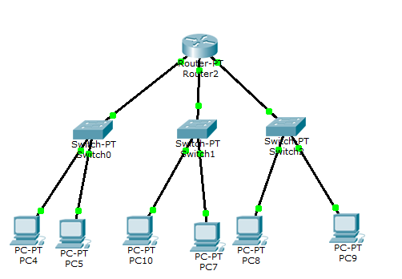
Send packets and ping commands and provide results with explanation.
Task 5: What are ICMP and ARP in cisco packet tracer?

